🔴🐶 BloodHound

Intro

BloodHound is a tool that is based on the theory of graphs, and what it is going to do is collect all the information from our Domain and objects to represent them in the form of Graphs 📊 with the relationships between them. This tool is probably going to be the most important, in terms of information collection in Active Directory Environment. This goes even beyond just collecting information, but also, it is a tool that will help us carry out vulnerability analysis.

The components of this tool will be two:

- The main application: This is what we are going to use to represent the objects of our domain and the relationships through a graphical interface. And they can be installed on any operating system, but in this case we will use Linux
- Collectors: These are some modules that Blood Hound offers us that we have to run on the machine that we have linked to Dominio so that it collects the information and then generates a .zip file that we will take to the machine where we have BloodHound, pass it to its interface and that will graphically represent the result. This collector is called sharphound. And if we want to use it against Windows systems we can use the sharphound.ps1

📥⚙️ Installation and Configuration

We can install this simply by performing:
sudo apt install bloodhound.

BloodHound is based on a non-relational database called neo4j. And to perform the initial configuration we only have to do from the command console:

sudo neo4j console

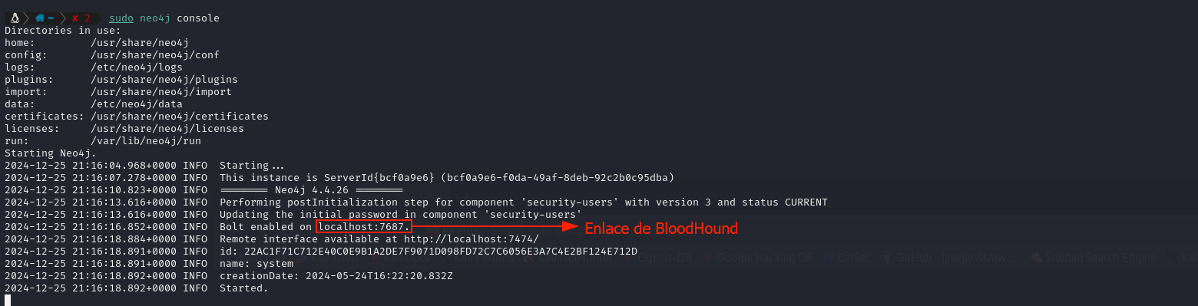

Then we enter the link so that we can access the graphical interface of the database from the browser.

Once inside, all we have to do is change the default password, which is neo4j (that is also the default user) put the password we want (or leave it as is my life :* ). The database neo4j will be running in the port 7687 from our local system, as you can see in the image above.

With this we only have to call the framework by placing it in our console bloodhound from the terminal, or by searching for the framework in the start menu, we log in and that's it 👌.
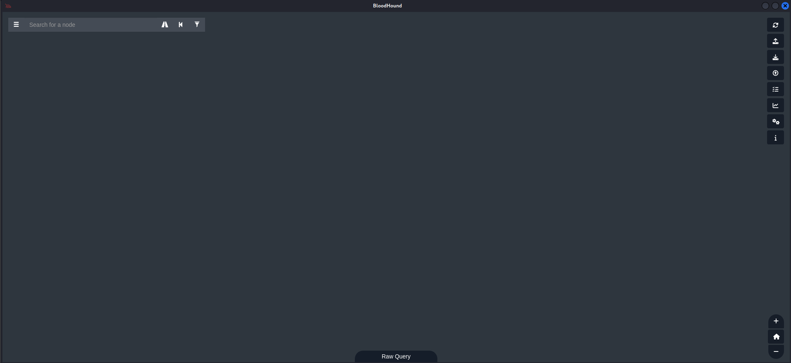

🦮 Hunting with bloodhound

The practical use of Bloodhound is as simple as going to the repository of GitHub from our Kali machine (Windows defender won't let us enter this repository), Go to Collectors, and once there open sharphound.ps1, view in Raw from GitHub and from the Raw visualization we copy the code and create a file with extension .ps1 on our Windows machine Active directory.
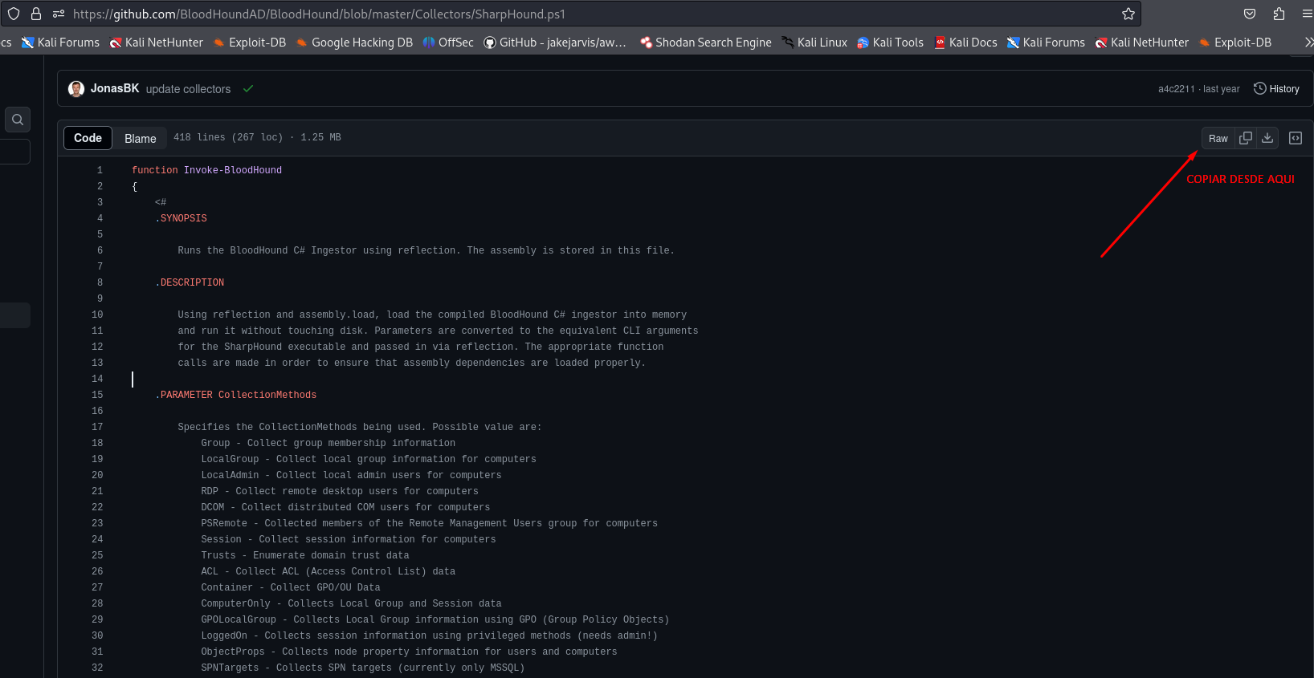

This powershell script will also be on the attacking machine where we have installed bloodhound, since installing this tool also downloads all the repo information, which includes this powershell script. This script is located in directory:
/usr/lib/bloodhound/resources/app/Collectors/SharpHound.ps1

We can copy the script and take it wherever we want.
He script of sharphound.ps We have to take it to our domain machine or to the computer that we have compromised (see file sharing 📤 File Transfer With Python Server) and execute the following from PowerShell on said Windows machine:

- . .\Nombredelscrip.ps1 (from the path where we created the file)
- Invoke-BloodHound -CollectionMethod All

This will generate a File .zip that we will transfer to the machine where we have installed BloodHound, following the method we prefer. And once executed BloodHound With the mouse cursor we pass the file .zip and we will now have access to all the mapping that has been done to the entire Domain server.

🐍🦮bloodhound-python

Sometimes the antivirus may block the script SharpHound.ps1. If this were to happen, there is another method to achieve this from our Kali machine with the utility bloodhound-python.

This utility will allow us to enumerate the domain by passing it a series of parameters, including the credentials of a domain user that we have compromised or that has been passed to us for auditing, the IP address of the domain controller and the domain name. The command would look like this:

bloodhound-python -u userAD -p "Password" -ns 10.10.20.5 -d dominio.local -c all --dns-tcp

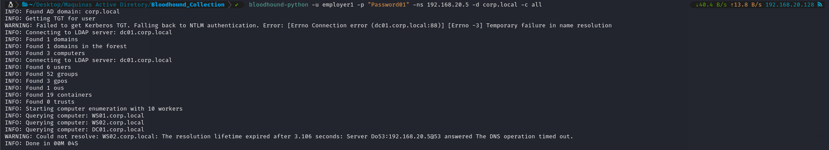

This will generate a series of .JSON files which are what we will pass bloodhound through Upload Data. 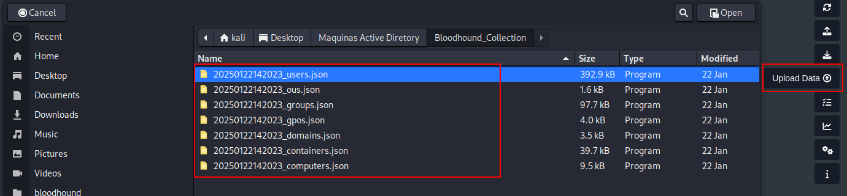

It is important to use the command from a particular folder, so as not to become a mess when we pass the files to bloodhound.

🦮 Bloodhound in action
With all that information that we have uploaded we can see all the domain information on graphs form:

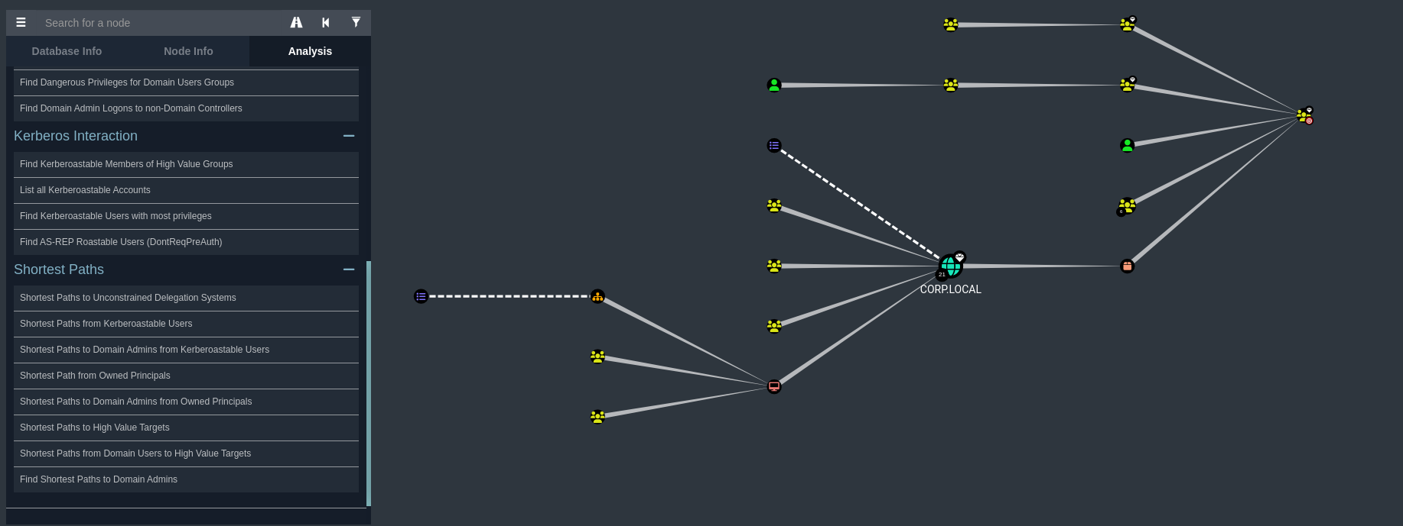

Now we can use bloodhound to enumerate all the domains, groups, objects, users... We can see all this information in a graphic and organized way.

And If you look closely at BloodHound, there are three sidebar options that are critical to navigating and understanding the information collected within the Active Directory graph.

- 📂 Database Info: shows us general information about the current database that BloodHound is using.

- 🧑‍💼Node Info: This option appears when we select a node (for example, a user, a group or a computer) within the graph and give us specific details about that node like properties of that object, direct relationships it has with other nodes and more

- 🧠 Analysis: This is where the magic happens. This section includes automated analysis tools to help you identify common attack paths.

As the lessons progress, we will see how we can use these Bloodhound functions when performing enumeration and attacks in AD environments. Without further ado, this lesson dedicated to bloodhound ends here.

